**PROJECT-NAME: BuyBooks India.com**

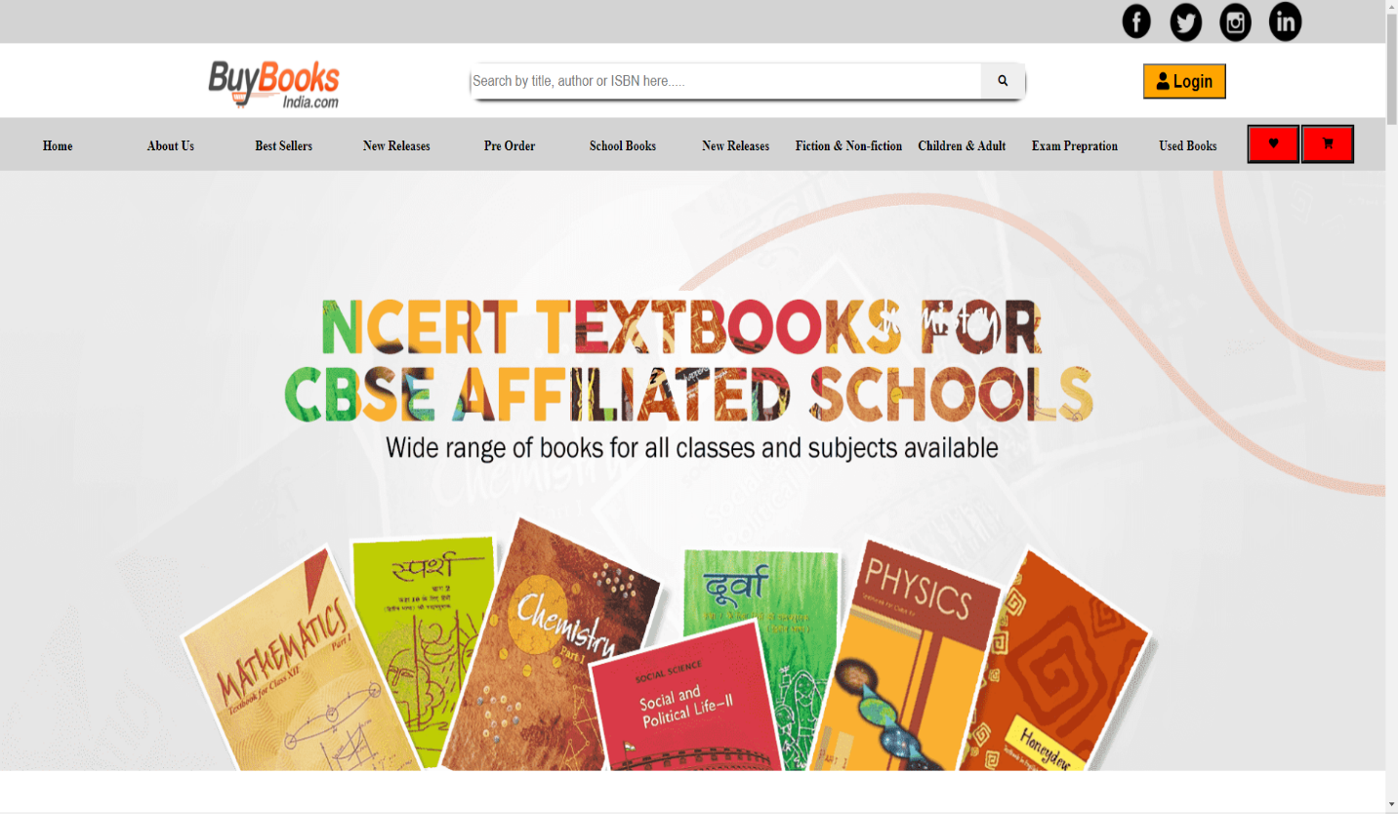

**OVERVIEW:** It’s an e-commerce website for a Book Store,

Here we can feature and sell books related to various categories like exam preparation, fiction non-fiction, newly released, Best-sellers, etc without any geographical constraint.

**HOME PAGE:**

* LOGO
* Social Media Icons
* Search Bar
* Buttons/icons - (Wishlist, My cart)
* Menu Bar (Text/Links)
* Main Banner - (IMAGE)
* Product Categories - ( clickable product cards, view more button)
* Discount Banners - (clickable Images)
* Footer – ( Copyright logo and designer name with some information)

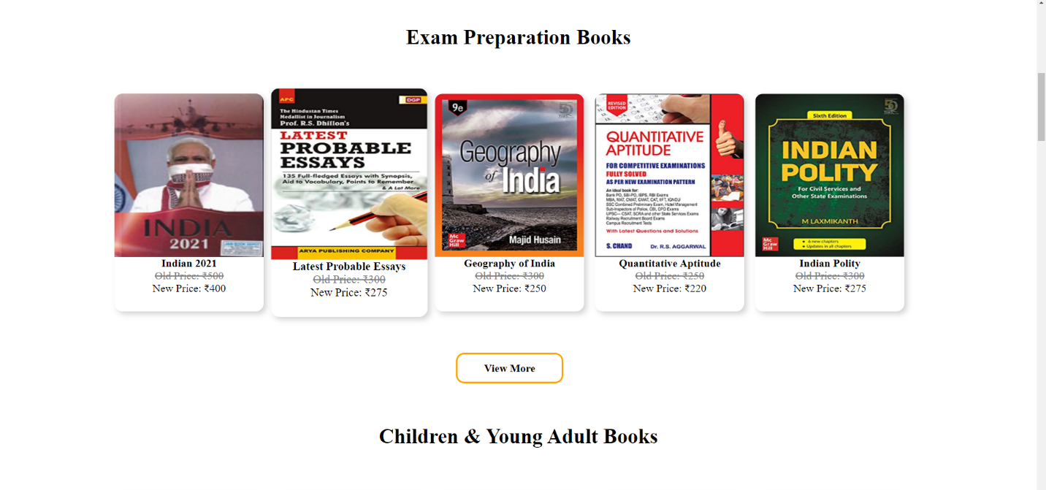

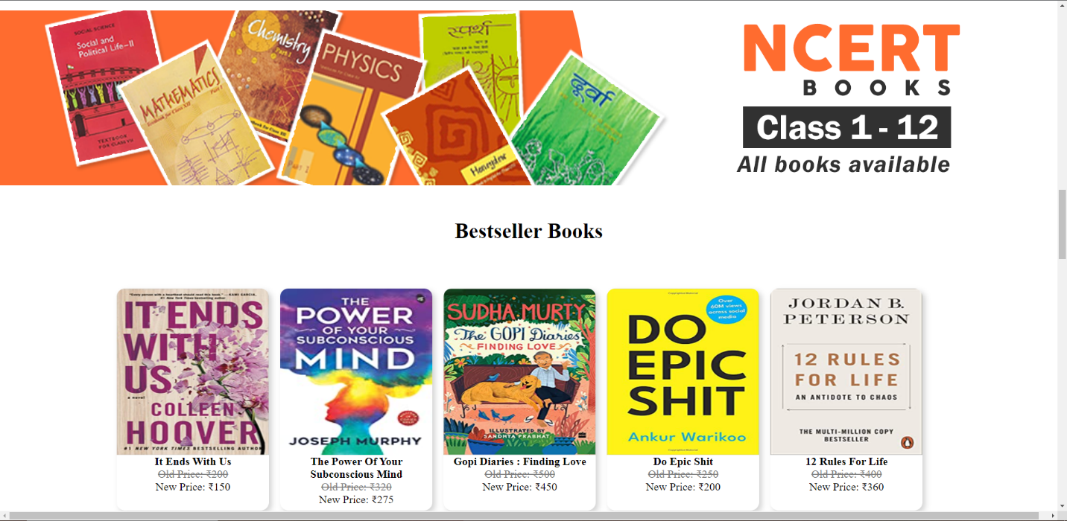

**MAIN PAGE/BOOKLIST PAGE:**

* Filters ( Categories, Author Name, Discount, Price)
* Product Cards (clickable Images, product name, prices)

**DETAILS PAGE:**

* Product Name
* Product price
* Product Images
* About Author
* About the book
* Product Specification
* Reviews
* Add to cart and Buy now Buttons

**REGISTRATION FORM:**

* E-mail address
* User Name
* Password
* Confirm Password

**Login Form:**

* E-mail address
* Password

**PAYMENT PAGE:**

* Order Summary
* Address Selection
* Payment method - (card, wallet, UPI, Net Banking, etc)